Team Coastal AGM
Via Zoom/Virtual
28 November 2022

Members in Attendance:

Chris Wilson
David Dunnigan (Host)
Cathy Butler
Chris Calverley
Mike Richter
Peter Orr
Les Suzuki
Teresa Stuart
Martin Kastelein
Roberto Henao
Kim Dunnigan
Bridget Perry-Gore

Meeting called to order at 7:03 pm.

Moved Mike Richter/Second by Peter Orr to accept 2021 AGM minutes - approved unanimously

President’s Report/year in review –Dave Dunnigan

- Year in Review- 81 members, 8 new. We had 66 renewals.
- Ride Leader Discussion: Special Rides each month and posted at the season start
- Cross-border rides return in 2023 in regular rotation Wednesday nights
- Resurrecting ‘Blood’Rides’ on Saturdays and possibly Wednesday night
- Exploring new ways of communicating:
  - A general dissatisfaction with WhatsApp because:
    - Don’t know who is in attendance
    - No emergency contact data readily available
    - Can gauge interest in a prospective ride.
  - Leaning toward a dedicated App likes TeamSnap- will explore with ride leaders over the winter. Will also investigate full capabilities of the website for special event registration
  - Survey of members
- Reinstating early bird rate (further discussion under new business)
- Saturday and Wednesday night rides in 2023, possible daytime weekday rides if interest is there.
- Continue to pay for ride leaders Strava account (for those who will use it)
- Survey members on desires, ride and route interests, clothing

Social Director Report – Bridget Perry-Gore

- Ride leaders did an awesome job this past year – thanks!
- January Holiday Party – cancelled due to COVID
- Bennett nights – Organized by Les
  - Monthly – try to organize a deal for summer 2023
- Learn to Gravel – Andy organized – X2
- Ice Cream ride - club paid for the ice cream
- Victoria Ride – 18 participants – August – 6th
- Gran Fondo – August 27th
  - 38 attendees
  - Catered Mexican-themed lunch paid for by the club
  - Prize drawing supported by Cap’s South Shore Cycle (organized by Les)

Treasurer’s Report – Cathy Butler
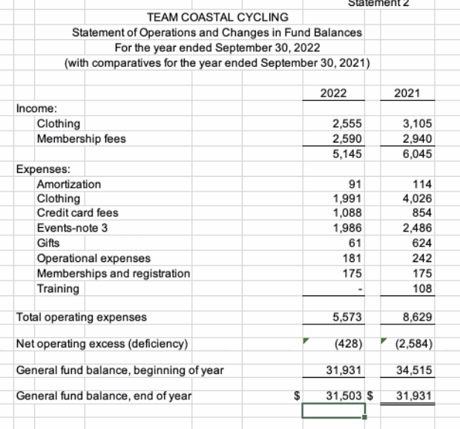

Credit Card fees – appear to include fees for website usage. Cathy will investigate further.

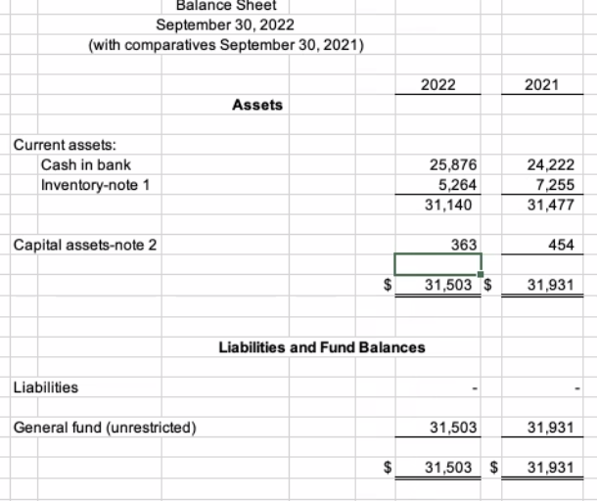

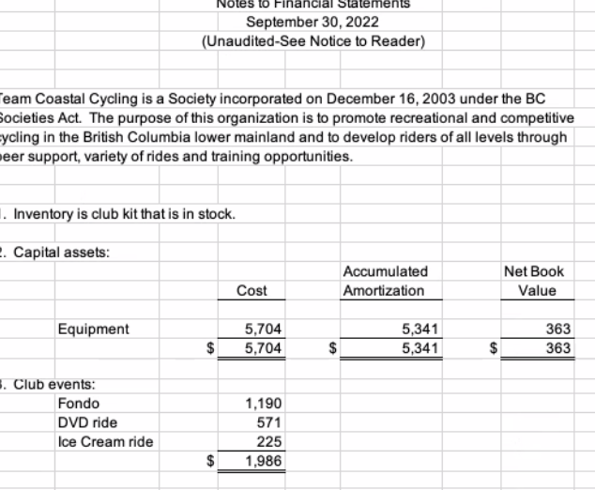

Team Kit – Les Suzuki

- Got caught up last year for inventory – placed a large order.
- Need to get more Men’s jersey/bib shorts in the most popular sizes
- With survey – will ask about interest in jackets and socks and water bottles

New Business – Dave Dunnigan

- Memberships

Motion to amend club membership fee as follows:
- $35 for NEW Members
- $35 for renewal before midnight January 31, 2023
- $45 after January 31, 2023
- Waived for Board and Directors (promote participation)
- Membership Stickers for Helmets Continue

Moved Chris Calverley / Seconded by Mike Richter – approved unanimously

- Communication

Motion: to approve the expenditure of up to $300 for the purchase of a dedicated app for scheduling club rides and special events.

Moved Les Suzuki / Seconded by Chris Calverley – approved unanimously

Proposed Board 2022-2023 members

- Roberto Henao – past President
- Dave Dunnigan – President
- Mike Richter – Vice President
- Chris Wilson – Secretary
- Cathy Butler – Treasurer & Registrar
- Teresa Stuart – Social Director
- Les Suzuki – Clothing Coordinator

No challenges or other nominations

Moved Mike Richter/ Seconded by Martin Kastelein to accept the board nominations – approved unanimously.

Thanks given to – everyone! Ride leaders, board members especially

Meeting closed at 7: pm – motion by Martin Kastelein / Seconded by Theresa Stuart – approved unanimously.
-

